# **Lesson Objectives**

1. Basic terms with quadratic functions
2. Determine if a function is linear, quadratic, or neither
3. Identify (or calculate) characteristics of quadratic functions and graphs
   1. Leading coefficient – opens up or down
   2. Vertex
   3. Axis of symmetry
   4. Intervals of increasing or decreasing
   5. Domain and Range
   6. Maximum or minimum value
4. Using vertex and standard form for a quadratic function

# **Basic Terms** with Quadratic Functions

**_________________** – a function of one variable where the highest exponent (degree) is 2.

Quadratic comes from the Latin *quadrare*, which means “to make square.”

Let *a*, *b*, and *c* be real numbers with *a* ≠ 0. A function represented by

$f\left(x\right)=ax^{2}+bx+c$

is a **quadratic function** (written in **_________________________ form**).

Let *a*, *h*, and *k* be real numbers with *a* ≠ 0. A function represented by

$f\left(x\right)=a{\left(x-h\right)}^{2}+k$

is also a **quadratic function** (written in **______________________ form**).

By contrast, a **____________________ function** is of the form:

$f\left(x\right)=ax+b$

where *a* and *b* are real numbers (*a* ≠ 0).

## Determine if a function is linear, quadratic, or neither

1. For both quadratic and linear, there must be ______ variables in the denominator.
2. Quadratic: Look for a term with *_____* in it (no _________________ exponents).

The leading coefficient is beside the *x*2.

1. Linear: Look for a term with just an *___* (exponent ___) in it (no higher exponents).

* **EXAMPLE:** Identify $f\left(x\right)=4-3x+5x^{2}$ as being linear, quadratic, or neither. If *f* is quadratic, identify the leading coefficient *a* and evaluate *f*(– 2). [3.1.1]

For both quadratic and linear, there must be NO variables in the denominator. ______

Quadratic: Look for a term with *x*2 in it (no higher exponents).

This function has the +5*x*2 term (no higher exponents), so this function is

**_____________________________**. The leading coefficient (beside *x*2) is *a* = **_____**.

Evaluate: $f\left(-2\right)$

Given Function: $f\left( x \right)=4-3 x +5{ x }^{2}$

Plug in – 2 for *x*: $f\left( \right)=4-3\left( \right)+5{( )}^{2}$

Be very careful with these negatives here.

Your placement of PARENTHESES is critical. Respect Order of Operations, too.

$$f\left(-2\right)=4________+5\left( \right)$$

$=4____________________=________________=_________$

You don’t have to do this by hand.

Using calculator: $f\left(-2\right)=4-3\left(-2\right)+5{(-2)}^{2}$

You still have to use parentheses correctly on calculator this way.

But remember, you can do the **“Go to the STO>”** method on the calculator:

Type in: **(-) 2, STO>, XTθn, ENTER** 

Then, type in the function formula with variables: $4-3x+5x^{2}$

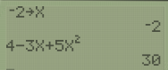

* **EXAMPLE:** Identify $f\left(x\right)=\frac{2}{x^{2}-1}$ as being linear, quadratic, or neither. If *f* is quadratic, identify the leading coefficient *a* and evaluate *f*(– 3). [3.1.3]

For both quadratic and linear, there must be NO variables in the denominator. _______

Although there is an *x*2 present, it is in the __________________________ of a fraction.

Since there is a variable in the denominator, this function *f*(*x*) is

**_________________________________________________________**.

* **EXAMPLE:** Identify $f\left(x\right)=\frac{1}{2}-\frac{7}{10}x$ as being linear, quadratic, or neither. If *f* is quadratic, identify the leading coefficient *a* and evaluate *f*(– 2). [3.1.5]

For both quadratic and linear, there must be NO variables in the denominator. ______

Quadratic: Look for a term with *x*2 in it. _________

Linear: Look for a term with just an *x* (exponent 1) in it (no higher exponents).

This function has the $__________$ term (no higher exponents), so this function is **___________**.

# Characteristics Quadratic Functions and Graphs

**_____________________________** – the _______-shaped graph of a quadratic function.

**Leading Coefficient (*____*)** – determines whether the parabola opens up or down.

If *a* > 0 (_________________________), the parabola opens ______________.

If *a* < 0 (_________________________), the parabola opens ______________.

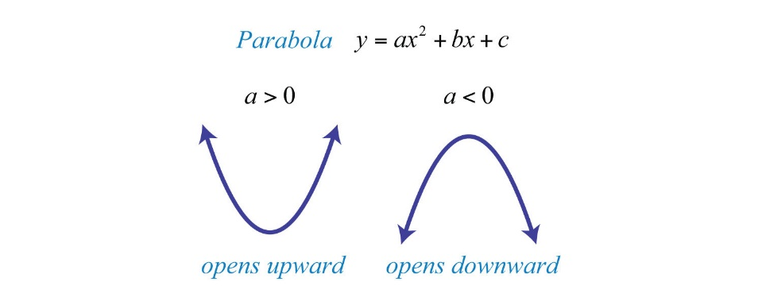

**__________________** – the highest point on a parabola that opens downward or the lowest point on a parabola that opens downward. It’s where the graph ____________________ from decreasing to increasing or vice-versa.

**_______________value** – the *y*-coordinate of the vertex of a parabola opening DOWN (*a* < 0)

**________________ value** – the *y*-coordinate of the vertex of a parabola opening UP (*a* > 0)

**Axis of Symmetry** – the _______________ line passing through the __________________. Equation is *x* = (*x*-Vertex)

**Increasing –** graph moves __________________________, from left to right

**Decreasing** – graph moves _________________________, from left to right

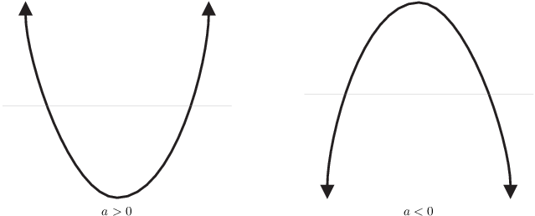

* **EXAMPLE:** Use the graph to find the following. [3.1.9]

|  |  |  |
| --- | --- | --- |
| * + 1. Sign of the leading coefficient | |  |
| * + 1. Vertex | |
| * + 1. Axis of Symmetry | |
| * + 1. Intervals where *f* is increasing and where *f* is decreasing | |
| * + 1. Domain and range | |
| **SOLUTION** | |
| 1. The parabola opens ________, so the **sign of the leading coefficient** is **____________**. | | |
| 1. The **vertex** is located at . | | |
| 1. The **axis of symmetry** (AOS) is the line $_____________________$. It goes through the vertex. | | |
| 1. On the **LEFT** side of the parabola, the function *f* is **____________________**. | On the **RIGHT** side of the parabola, the function *f* is **______________________**. | |
| Written as inequality: $___________________$ | Written as inequality: $__________________$ | |
| Interval Notation: $_______________________$ | Interval Notation: | |
| 1. The **domain** of *f* is describing ***_____***, and it moves **_______-to-__________**.   (Use the *x*-axis to help you.)  Written as inequality: _________________  Interval Notation: ___________________ | The **range** of *f* is describing ***____***, and it moves **______-to-____________**.  Always use bracket with an included value!  (Use *y*-axis to help you.)  Written as inequality: _______  Interval Notation: _______________ | |

* **EXAMPLE:** Use the graph of *f* to determine the intervals where *f* is increasing and where *f* is decreasing. [1.4-28]

|  |  |  |
| --- | --- | --- |
| * **(STEP 1)** ***x*-Vertex ____________**   (the *x*-coordinate of the vertex) | |  |
| * **(STEP 2) Write out LEFT & RIGHT sides.** | |
| **LEFT** side  of the parabola | **RIGHT** side  of the parabola |
| Written as Inequality: | |
| **______________** | **_______________** |
| Interval Notation: | |
| **______________** | **_______________** |
| * **(STEP 3) Who’s** Increasing or Decreasing? | |
| **______________** | **_______________** |

**ANSWER: Increasing ________________** and **Decreasing ________________**.

## **Vertex Form**: $f\left(x\right)=a{\left(x-h\right)}^{2}+k$ Vertex is **(, )**

*y*-Vertex is *k*

(*y*-coordinate of vertex is OUTSIDE parentheses)

**_________ SIGN** outside – **________ IT**

*x*-Vertex is *h*

(*x*-coordinate of vertex is INSIDE parentheses with *x*)

**_______________ SIGN** with *x*

*a*  is the leading coefficient

(opens $∪or∩$)

* **EXAMPLE:** Identify the vertex of the parabola and determine whether its graph opens upward or downward. [*Hornsby 3.2.17]

$$f\left(x\right)={\left(x-9\right)}^{2}-3$$

**SOLUTION**

INSIDE parentheses with *x*, SWITCH SIGN. I see – 9 with *x*, so ***x*-Vertex is _____**

OUTSIDE parentheses is *y*, SAME SIGN (keep it). ***y*-Vertex is _____**

The vertex is therefore $( , )$

The leading coefficient *a*, is an understood value of _____.

That is, $f\left(x\right)={\left(x-9\right)}^{2}-3$ can rewrite as $f\left(x\right)={ \left(x-9\right)}^{2}-3$***a* = ____**

Since *a* = 1, that’s a POSITIVE number, which **opens __________________**.

* **EXAMPLE:** Give the largest interval where the function increases or decreases, as requested. $f\left(x\right)={\left(x+3\right)}^{2}+6$; increases [*Hornsby 3.2-30]

**SOLUTION**

* **(STEP 1)** Does the parabola open **UP** or **DOWN**?

Leading coefficient, *a*, is understood value of ___ (positive). It opens **______**.

* **(STEP 2)** Make a **_________________** of a parabola opening **UP**.

$f\left(x\right)={\left(x+3\right)}^{2}+6$ 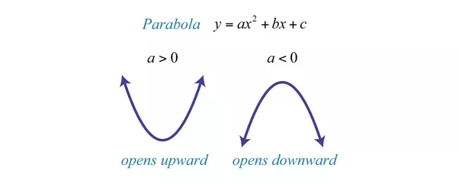

$$x=__________$$

* **(STEP 3) *x*-Vertex** (SWITCH SIGN)
* **(STEP 4) Write out LEFT & RIGHT sides.**

**LEFT** side of parabola **RIGHT** side of parabola

Written as Inequality:

_________________ ___________________

Interval Notation:

_________________ ___________________

* **(STEP 5 ) Who’s INCREASING or DECREASING**?

**LEFT** side is **_____CREASING RIGHT** side is **_____CREASING**

What we’re after: increases 

$$x=-3$$

**ANSWER is: $( , )$**

(go on to the next page)

## **Standard Form: $f\left(x\right)=ax^{2}+bx+c$** Vertex Formula: $\left(-\frac{b}{2a}, f\left(-\frac{b}{2a}\right)\right)$

***a***

leading coefficient

beside ________

***y*-Vertex**

**__________ ______ *x***-Vertex into function to get   
*y*-Vertex.

***x*-Vertex**

Use this little formula

$$x=\frac{ }{ }$$

***c***

has $x$

_____

***b***

beside the ____

* **EXAMPLE:** **(a) Use** the vertex formula to find the vertex. [3.1.47]

**(b)** Find the intervals where *f* is increasing and where *f* is decreasing.

$f\left(x\right)=8-x^{2}$

**SOLUTION**

Since this function has no parentheses with *x*, then it’s in _________________ form.

The terms are not in the right order. Rewrite them highest power to lowest.

$f\left(x\right)=8-x^{2}$ rewritten in correct order: $f\left(x\right)=_________________________$

It’s missing the *x*-term, so write in a zero placeholder: $f\left(x\right)=-x^{2}+0x+8$

1. The vertex formula is $x=\frac{-b}{2a}$ $b=_____,a=______$ $x=\frac{-0}{2∙\left(-1\right)}=_____$

***x*-Vertex = ____** Plug in *x* into function (use parentheses) in order to get *y*.

$f\left(x\right)=-x^{2}+8$ $f\left(0\right)=_____________________$

___________________

***y*-Vertex = ____** Therefore, the coordinates of the vertex are: $( , )$

(go on to the next page)

(continued from previous page)

* **EXAMPLE:** **(a) Use** the vertex formula to find the vertex. [3.1.47]

**(b)** Find the intervals where *f* is increasing and where *f* is decreasing.

$f\left(x\right)=8-x^{2}$

**SOLUTION**

$f\left(x\right)=8-x^{2}$ means the same thing as $f\left(x\right)=-x^{2}+8$

1. To find intervals of increasing and decreasing:

* **(STEP 1)** Does the parabola open **UP** or **DOWN**?

Leading coefficient, *a*, is understood value of ____ (negative). It opens **___________**.

* **(STEP 2)** Make a **SKETCH** of a parabola opening **DOWN**.

 $f\left(x\right)=-x^{2}+8$ Vertex is $(0,8)$

$$x=0$$

* **(STEP 3) *x*-Vertex**
* **(STEP 4) Write out LEFT & RIGHT sides.**

**LEFT** side of parabola **RIGHT** side of parabola

Written as Inequality:

_________________ ___________________

Interval Notation:

_________________ ___________________

* **(STEP 5 ) Who’s INCREASING or DECREASING**?

**LEFT** side is **______CREASING RIGHT** side is **______CREASING**

What we’re after: (both) 

$$x=0$$

**ANSWER is:** **DECREASING** on ______________ and **INCREASING** on _______________

* **EXAMPLE:** Identify where *f* is increasing and where *f* is decreasing

$f\left(x\right)=280x-70x^{2}$ [1.4.79]

**SOLUTION**

Reorder the function into correct standard form: $f\left(x\right)=___________________________________$

* **(STEP 1)** Does the parabola open **UP** or **DOWN**?

Leading coefficient, *a*, is ______ (negative). It opens **____________**.

* **(STEP 2)** Make a **SKETCH** of a parabola opening **DOWN**.



$f\left(x\right)=-70x^{2}+280x+0$

$$x=________$$

* **(STEP 3) *x*-Vertex**

The vertex formula is $x=\frac{-b}{2a}$ $b=________,a=________$ $x=\frac{ }{ }=\frac{ }{ }=$

We don’t need the *y*-Vertex because we’re only finding intervals of increasing and decreasing. These only use ***x*-Vertex**.

* **(STEP 4) Write out LEFT & RIGHT sides.**

**LEFT** side of parabola **RIGHT** side of parabola

Written as Inequality:

_________________ ___________________

Interval Notation:

_________________ ___________________

* **(STEP 5 ) Who’s INCREASING or DECREASING**?

**LEFT** side is **_____CREASING RIGHT** side is **_____CREASING**



$f\left(x\right)=-70x^{2}+280x+0$

$$x=2$$

**ANSWER:** Over the interval _____________________ the function *f* is **increasing**.

Over the interval _____________________ the function *f* is **decreasing**.

## **Find the Maximum or Minimum Value of a Quadratic Function**

That’s the job of the *y*-coordinate of the vertex. **Max./Min…use *____*-Vertex**

* **EXAMPLE:** If a football is kicked straight up with an initial velocity of 64 ft/sec from a height of 4 feet, then its height above the earth is a function of time given by

$$h\left(t\right)=-16t^{2}+64t+4$$

What is the maximum height reached by the ball? [3.1.123]

**SOLUTION**

For convenience, let’s rewrite the function $h\left(t\right)=-16t^{2}+64t+4$ as

* **(STEP 1)** Does the parabola open **UP** or **DOWN**?

Leading coefficient, *a*, is _______ (negative). It opens **____________**.

* **(STEP 2)** Make a **SKETCH** of a parabola opening **DOWN**.



$f\left(x\right)=-16x^{2}+64x+4$

$$x=_____$$

* **(STEP 3) *x*-Vertex**

The vertex formula is $x=\frac{-b}{2a}$ $b=______,a=_______$ $x=\frac{ }{ }=\frac{ }{ }=$

* **(STEP 4) *y*-Vertex**

Since ***x*-Vertex = 2** ________ ____ *x* into function (use parentheses) in order to get *y*.

$f\left(x\right)=-16x^{2}+64x+4$ $f\left(2\right)=-16{ \left( \right)}^{2}+64( )+4$

$=-16\left( \right)+ +4= + =$

The ***y*-Vertex = _______** Therefore, the maximum height reached by the ball is **_______**ft.

Sources Used:

1. MyLab Math for *A Graphical Approach to College Algebra*, 7th Edition, Hornsby, Pearson Education Inc.
2. MyLab Math for *College Algebra with Modeling and Visualization*, 6th Edition, Rockswold, Pearson Education Inc.
3. Number Line Inequalities (modified) from Desmos, <https://www.desmos.com/calculator/evxn1e1njv>, © 2019, Desmos, Inc.
4. Wabbitemu calculator emulator version 1.9.5.21 by Revolution Software, BootFree ©2006-2014 Ben Moody, Rom8x ©2005-2014 Andree Chea. Website <https://archive.codeplex.com/?p=wabbit>